**Data Mining and Data Warehousing Model Lab**

**1)Download a suitable dataset for classification from any Repository. List the attributes and its type in a word Doc.**

Dataset that contains attributes of glucose and blood pressure that classifies diabetes.

1. Glucose level - Interval Scaled
2. Blood Pressure - Interval Scaled
3. Diabetes - Binary

**2). Load the dataset and implement Naïve Bayes Classification algorithm using python. Divide the dataset to Training set and testing set. Calculate probabilities and build prediction model. Print the Prediction for Test set, confusion Matrix and accuracy.**

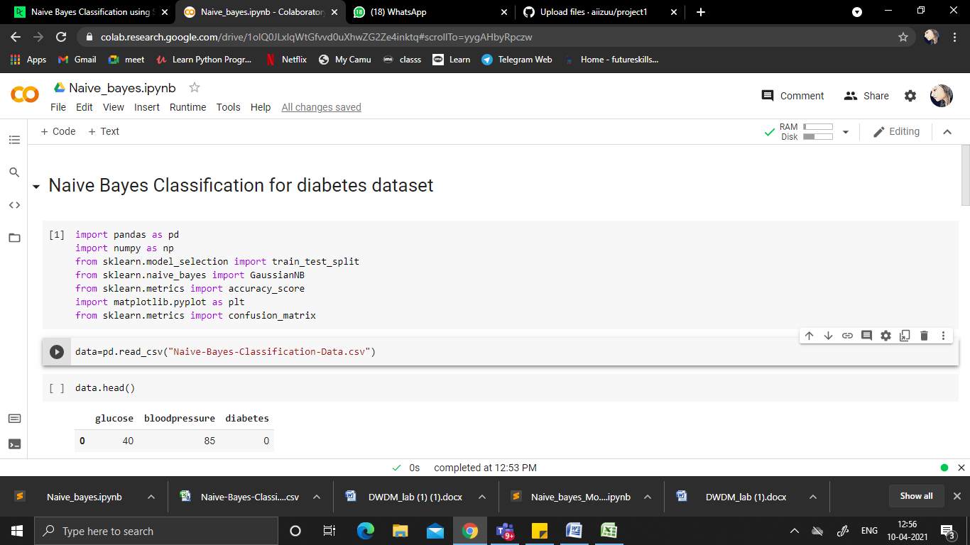

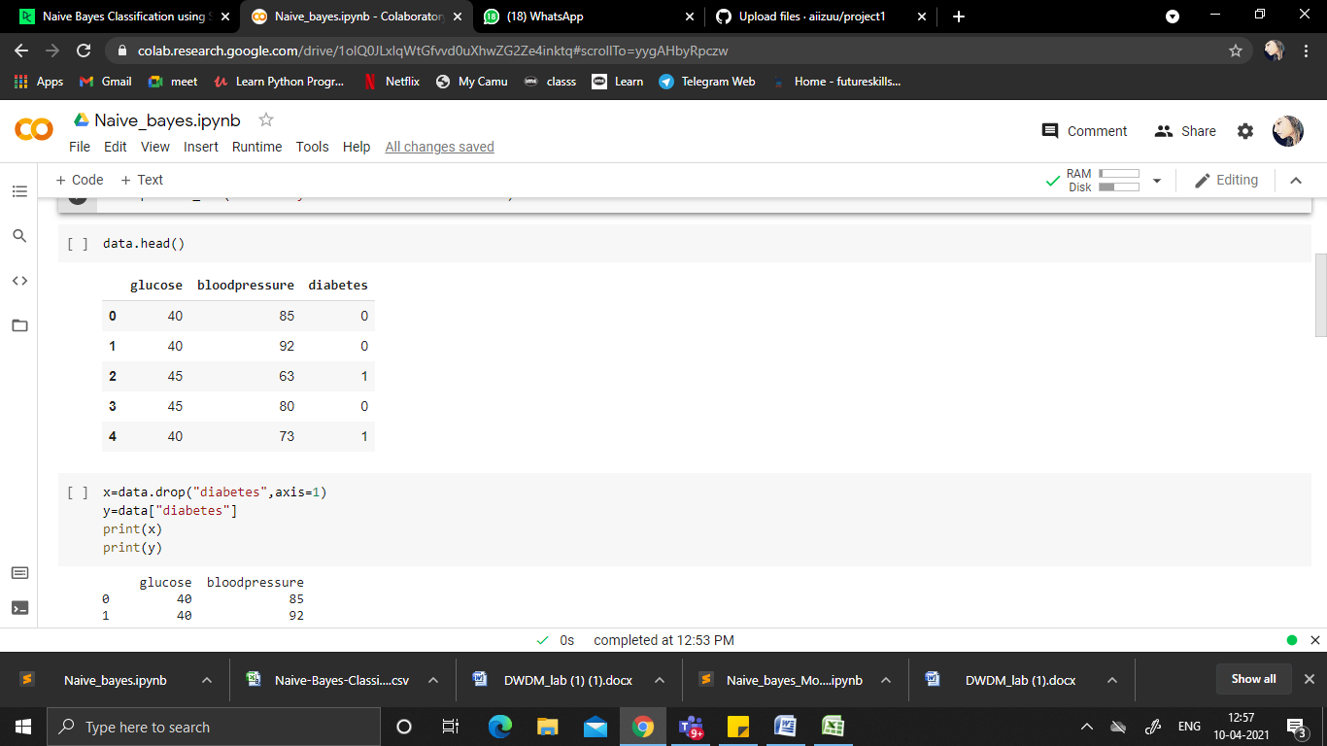

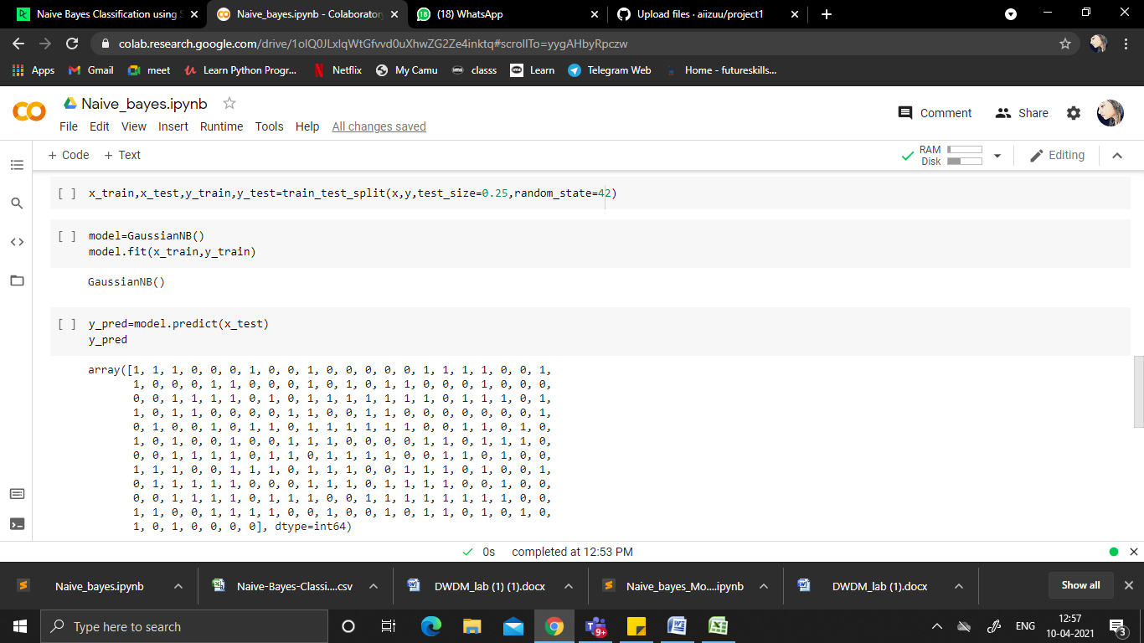

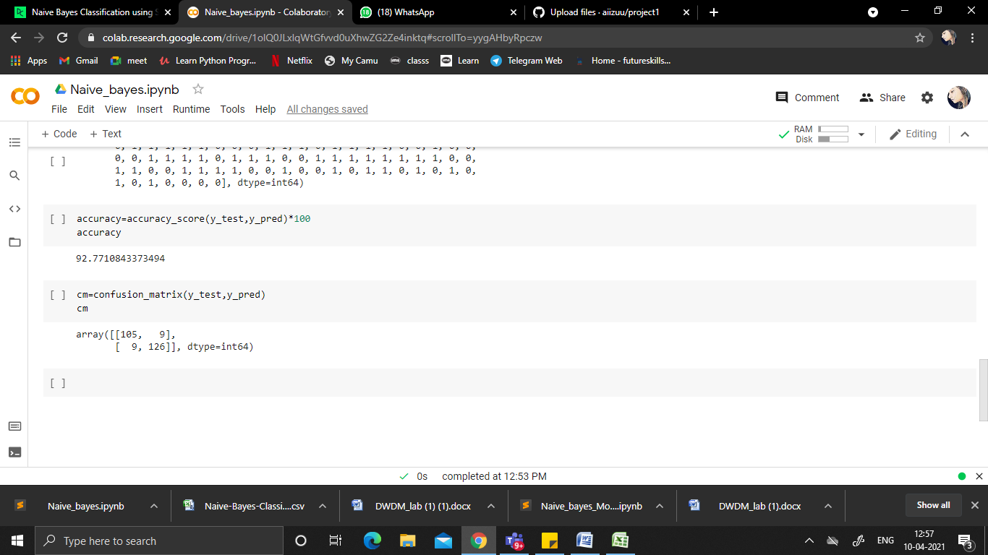

**3) Upload in your github account. Provide the link for access.**

[**https://github.com/aiizuu/project1**](https://github.com/aiizuu/project1)